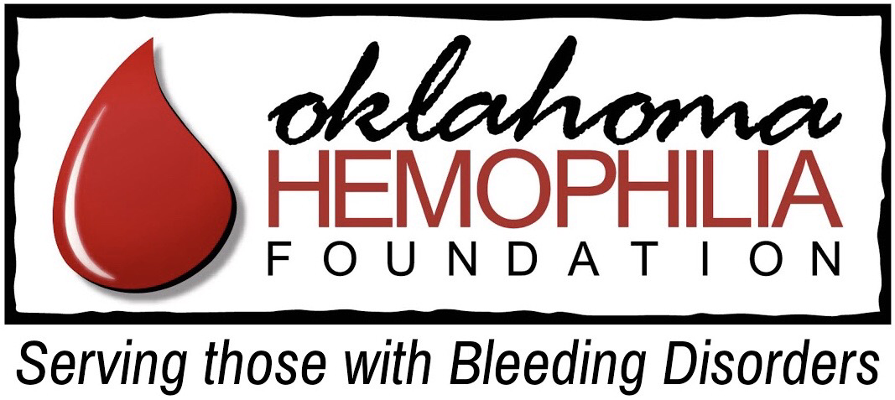
OHF Benevolence Program Application
The Oklahoma Hemophilia Foundation may, at the discretion of its Officers and Board, provide emergency short-term financial assistance to members of the Oklahoma bleeding disorders community through its Benevolence Program.
Before an application can be considered, this application must be completed by the person seeking assistance and returned with all the requested documents to: tgrogan@okbleedingdisorders.org.
All the information you submit will be treated as confidential. Your application will be reviewed as rapidly as possible, and you will be notified of the decision. Please remember that because of limited resources, not all requests can be granted.
- Name:

- The reason for the request:

- The amount of assistance requested:
(Please attach copies of all bills documenting the amount. You may scan or make a copy by taking a picture with your phone. All approved assistance payments will be made directly to the party to whom the money is owed. If a payment is approved, you will need to contact the party to whom the money is owed to let them know that the Oklahoma Hemophilia Foundation will be paying the bill and the date that payment will be made. Ask the party being paid to delay any disruption of service or other adverse action.)

- If you have received a suspension of services, eviction, or foreclosure notice, please attach a copy. What is the date that action must be taken to prevent adverse action?

- You need to contact the 211 hotline for social services (located in the resources section of the OHF website) prior to submitting this application. When did you do so and what was the result?

- You also need to contact the Oklahoma Center for Bleeding Disorders Social Worker prior to submitting this application to seek assistance of a more permanent nature at 405-271-3361 or 1-800-688-5288. We will follow up with the Social Worker to verify a plan has been made to deal with the reason leading to the need for assistance. Please sign and attach the Information Release form from our website so we may contact the social worker.

- Please verify and sign below: I verify that the above information is correct to the best of my knowledge and that I have not received benevolence funds from OHF in the past 12 months.

Name:_______________________________________________ Date:_______________

